Project Design Phase-II - Technology Stack & Architecture
Date | 12 August 2026
Team ID | N/A
Author / Team Member | Ruturaj Misal
Project Name | ShopEZ Ecommerce Application
Maximum Marks | 4 Marks

Author: Ruturaj Misal
ShopEZ leverages the MERN technology stack (MongoDB, Express.js, React, Node.js) paired with modern tooling like Vite, Axios, Multer, and JWT to achieve high performance, responsive UI, and developer productivity.
System Architecture & Technology Diagram:

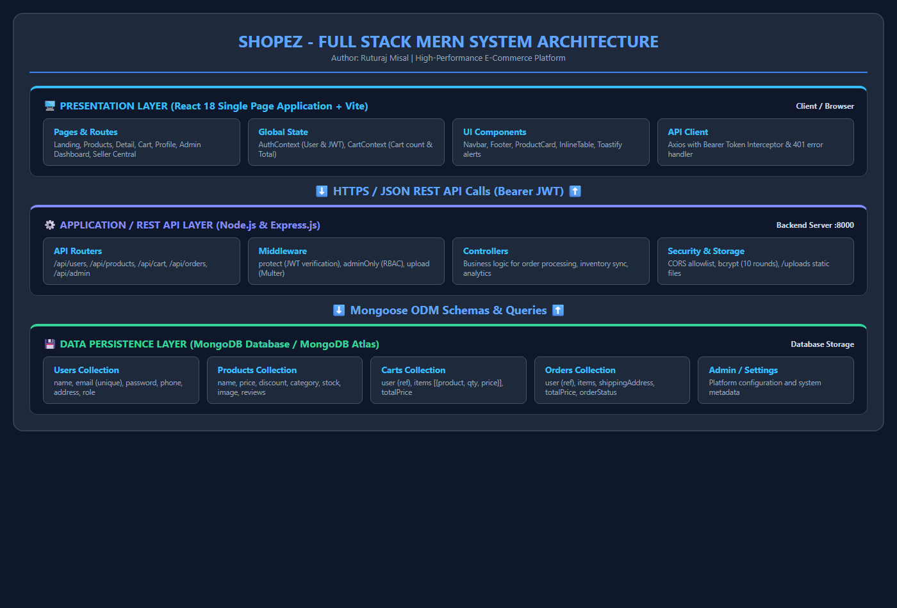
Figure 7: Full Stack MERN Technology Architecture

S.No | Layer / Component | Technology | Role & Justification in ShopEZ
1 | Frontend Library | React 18 / 19 | Declarative component-based UI for seamless single-page application navigation without page reloads.
2 | Build Tool | Vite | Ultra-fast HMR (Hot Module Replacement) and optimized production asset bundling.
3 | Client-Side Routing | React Router DOM | Declarative client-side routing, nested routes, and ProtectedRoute guards for users and admins.
4 | State Management | React Context API | Global state management for user authentication (AuthContext) and cart items (CartContext).
5 | HTTP Client | Axios | Promise-based HTTP client with request interceptors to inject JWT bearer tokens.
6 | UI Feedback & Icons | React Icons, React Toastify | Intuitive visual iconography and toast alerts for cart updates, login success, and errors.
7 | Backend Framework | Node.js & Express.js | Asynchronous, event-driven REST API server following MVC architectural patterns.
8 | Database | MongoDB & Mongoose ODM | Schema-based document data modeling for Users, Products, Carts, and Orders with timestamps and hooks.
9 | Authentication | JSON Web Tokens (JWT) | Stateless bearer token authentication ensuring secure communication between client and server.
10 | File Upload | Multer | Multipart/form-data handler for uploading product images to server storage.

